**Day 5.1 – Web Hosting**

Two common web hosting service providers are “GoDaddy” and “SquareSpace”. Complete the table below to compare these services and to learn more about web hosting.

1. Resources to learn about web hosting providers are as follows:
   1. SquareSpace – www.squarespace.com
   2. GoDaddy - ca.godaddy.com
2. Complete the following table.

|  |  |  |
| --- | --- | --- |
| Topic | SquareSpace | GoDaddy |
| Website Hosting   * Template Based Web Design * Survey tools and other applications * Internationalization * Professional Design Service * Website Analytics * Backup & Restore | - Their award-winning templates are the most beautiful way to present your ideas online.  - Stand out with a professional website, portfolio, or online store. Present your work using Squarespace’s professional portfolio designs.  - Display projects in customizable galleries and add password-protected pages to share private work with clients.  - Learn where your website traffic is coming from, what your visitors are looking for, and how they’re interacting with your content or products through our in-depth Analytics tools. | - For professional uses  Four hosting plans  Once you purchase a Web hosting plan, GoDaddy stores your site on one of their servers and assigns it a unique DNS.  - The DNS serves as the address that allows people around the world to find and view your website.  - This unique address is required in order for people to view your site.  - They support Windows and Linux hosting. |
| E-Commece   * On-Line Store Support * Check-Out Cart Management * Credit Card Payment Processing * SSL Certificates | - Think of Squarespace as your very own IT department, with free, unlimited hosting, top-of-the-line security, an enterprise-grade infrastructure, and around-the-clock support.  - Get personalized support from our Customer Care Team via email or live chat, or join a live webinar.  - Reach out any time — they’re here 24/7 | - An SSL Certificate protects the data going to and from you site — from personal info to credit card numbers — making it impossible for hackers to read them.  - And when visitors feel safe, they’re more likely to give you their business. |
| Professional Email   * Domain Name Registration * Domain Name Transfer * DNS (Name Service) * Web Mail * IMAP / POP3 Support | - Buying a domain with Squarespace is simple and straightforward.  - There are no hidden fees, price hikes, or ads.  - All Squarespace sites on an annual plan include one custom domain, free for its first year.  - Additional domains are between $20 and $70 per year.  - If you registered a domain through Squarespace and want to use it with a different Squarespace site, you can move it from your Domains panel.  - If you delete your Squarespace site, you'll have the option to let your domain expire, renew it for an annual fee, or transfer to a new provider.  - If you renew, you'll continue to manage the domain through Squarespace.  - If you’ve already got a domain from a third-party provider, you can simply transfer it to Squarespace | - Everyone has email, but that doesn’t mean all email is the same.  - Customers are nine times more likely to choose a business with a professional address like [you@ludlow.biz](mailto:you@ludlow.biz).  - They give people the choice to create emails from the site. |
| Other Services   * Blogging * Cloud File Storage * Media Streaming | - Take advantage of their powerful blogging tools to share your story, post company news, or announce a product release. Categorize, share, and schedule your posts to make your content work for you. | - If you’ve built your website in a HTML editor, like Dreamweaver or Microsoft Expression Studio, you have to upload your website files via FTP (File Transfer Protocol).  - We have a built-in FTP File Manager that you can access in their Hosting Control Center  Moving your website to GoDaddy is a simple process. |

**Day 5.2 – Internet Service Provider (ISP)**

Internet Service Providers (ISPs) provide hardware and software services to connect your LAN (in your house or your business) to the Internet.

Two most popular ISPs in Ontario are Bell and Rogers, but there are other choices.

Select an alternative ISP that operates in Southern Ontario to answer the following questions. Suggestions are:

* Primus - <https://primus.ca/>
* ExecuLink - <https://www.execulink.ca/>
* Xplorenet - <https://get.xplornet.com/>
* Start.ca - <https://www.start.ca/>

1. What residential (i.e. home) service packages do they provide?
   1. Bandwidth Speed (both upload & download)

- Speeds up to 250 Mbps

* 1. Data Limits (and cost for exceeding limits)

- Unlimited Internet

- You will receive notifications when you are approaching your Mobility data limit

* 1. Connection Technologies (e.g. cable, WiFi, DSL, etc.)

- Wi-Fi Connectivity

- 24/7 Technical Support

- Though the internet services we offer vary depending on your postal code, we are quite consistent, and we remain above the grade.

- Over the years, the internet and its technological counterparts, such as TV, home phones, and mobility, have become synonymous needs.

- With this understanding, we have evolved to offer these services and have been doing so for over 114 years

1. What business packages do they provide?
   1. Bandwidth Speed (both upload & download)
   2. Data Limits (and cost for exceeding limits)

- 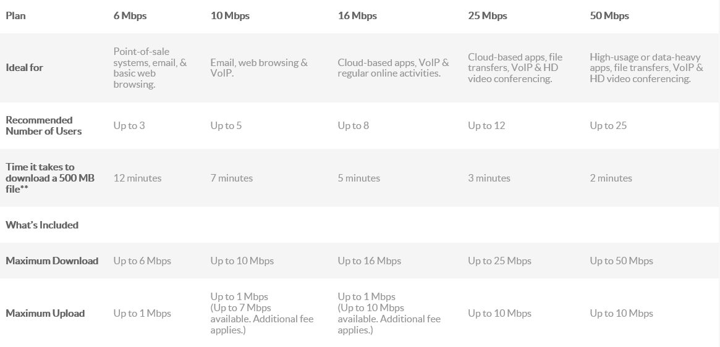-

* 1. Connection Technologies (e.g. cable, WiFi, DSL, etc.)

- DSL is an affordable High Speed Internet solution for your business that has the capabilities you need. From a standard DSL connection to a solution tailored to your business, we’ll customize a solution to suit your business’ unique situation.

- Up to 16 Mbps Up to 1 Mbps Unlimited

1. What extra security services do they provide? (e.g. Anti-Spam & Virus scanning, Firewall Protection)

- Free SpamGuard and VirusGuard protection to scan all inbound emails sent to an Execulink email account.

1. What other services do they provide? (e.g. Digital Phone, Voice over IP (VoIP), Television)

- 7 Free calling features

- Call Display included

- Call Waiting included

- Affordable Long Distance options

- Affordable Voicemail options

- The Starter Pack comes with 25+ channels. A perfect base to build your Link TV service on.